**POV Daily Report update to get JIRA issue details**

**Integration Name:** POV Daily Report Automation

**Problem Statement:** POV integration of the daily status report has code functionality to fetch ticket information from iDB. Since we have now moved from iDB to Jira, we want to update this POV to fetch ticket information from Jira.

**Proposed Solution:** Replace current API set-up built for iDB endpoint with that of JIRA endpoint.

**Assumption:**

1. All clients are using POV to create JIRA ticket for integration failure. If not, then they need to create JIRA ticket for failed/completed with error events with Summary same as Integration event text. This integration provides integration event text as parameter to JIRA API to get details such as JIRA Issue/Ticket Number and Integration Monitoring Notes.
2. Integration Monitoring Notes of JIRA issue/ticket should be updated by Support person for each ticket/issue as this data will flow to Comments section in daily report.

**Steps to be taken:**

1. **Authentication and Authorization for JIRA API:**

We are using basic authentication for JIRA API calls. For this, we should have an Atlassian account which should have access to your AMS project over JIRA. Actual physical account is not preferrable here but, you can use actual accounts with permission of respective onshore/offshore leads.

**Most important:** JIRA has deprecated basic authentication using account password instead, we need to use an API token which has expiry of 1 year. Hence, we need to create API token for our account and that can be used as a password for our API calls. Please follow below steps to generate Access Token:

1. Navigate to *Security* of your account:

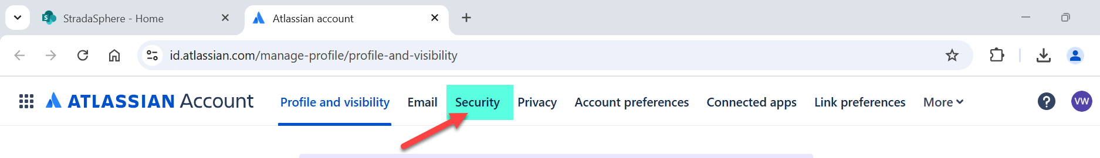

1. Scroll Down and click on *Create and manage API tokens:*

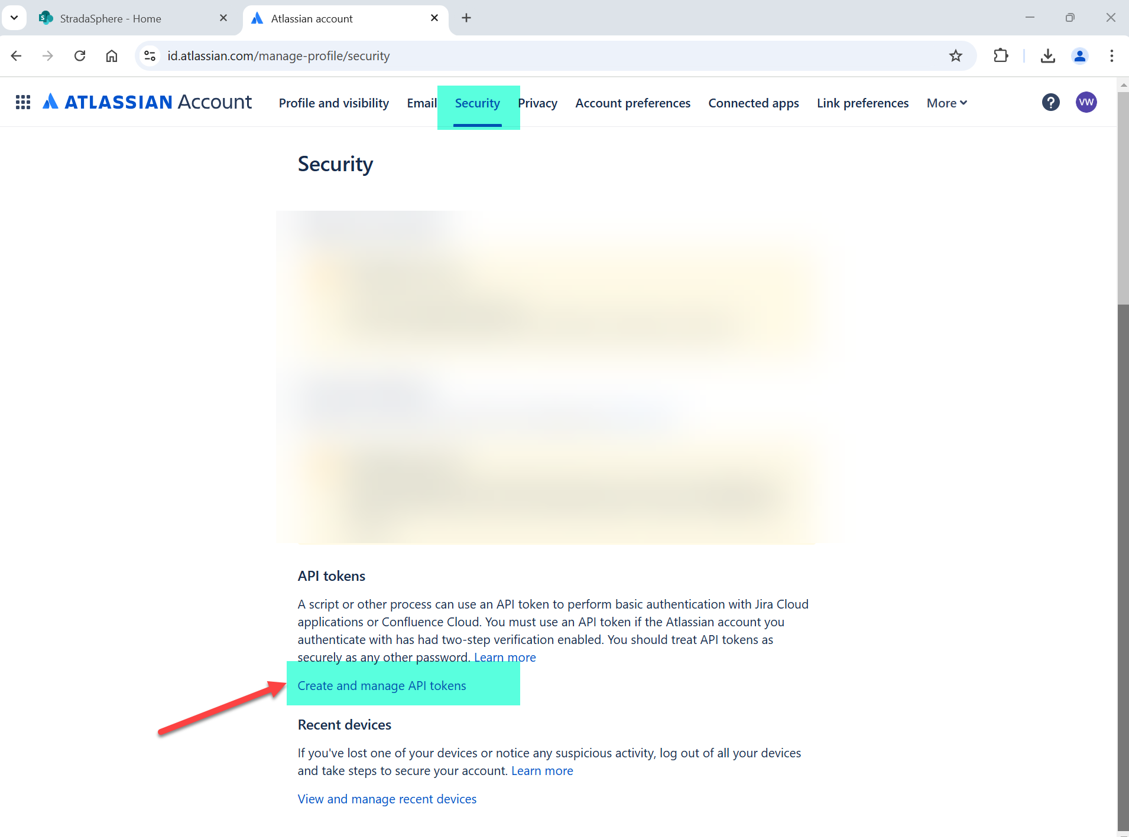

1. Click on *Create API token:*

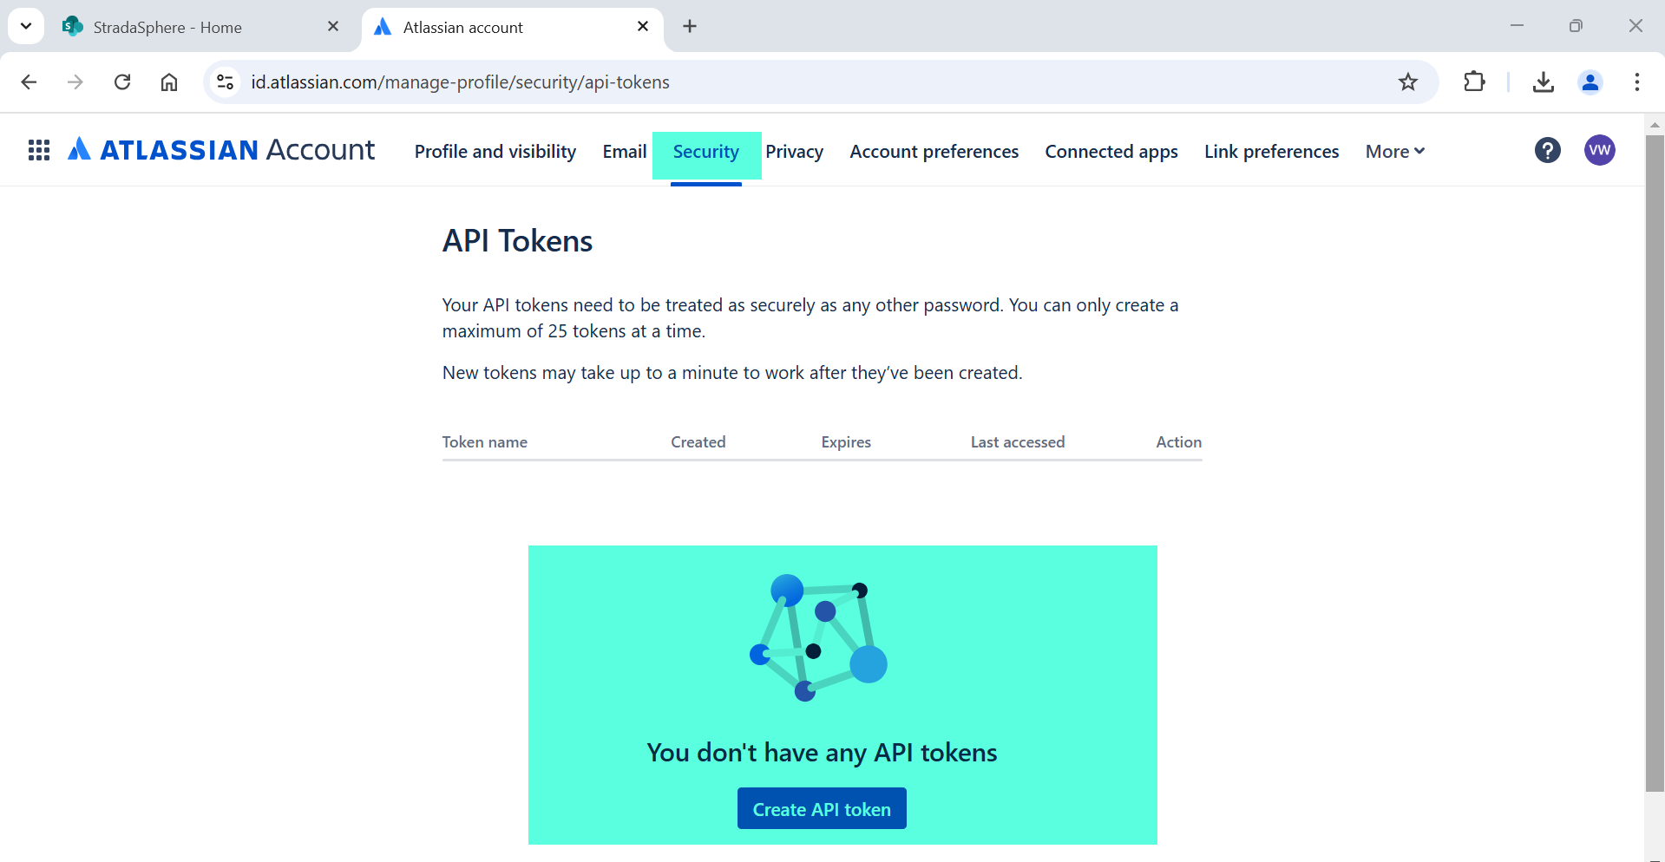

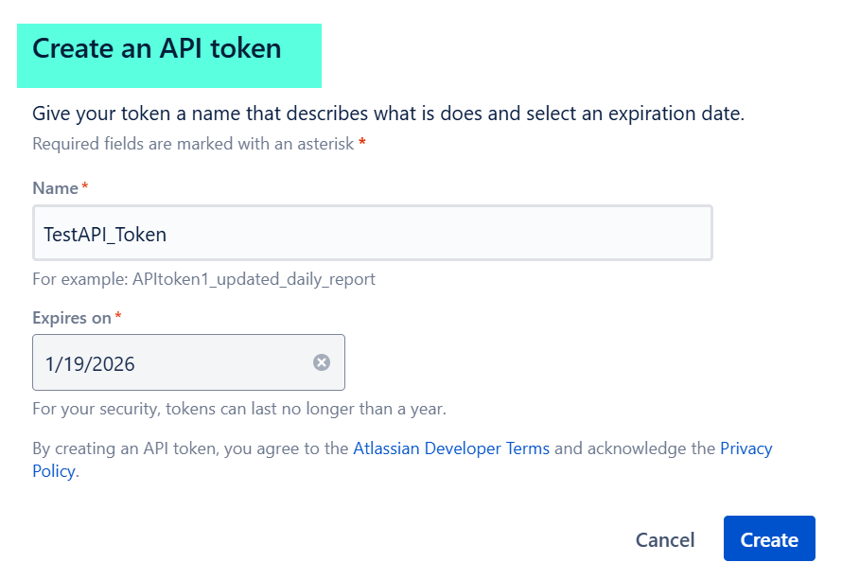

1. Copy this token and store in integration attribute to use it as a password for API call:

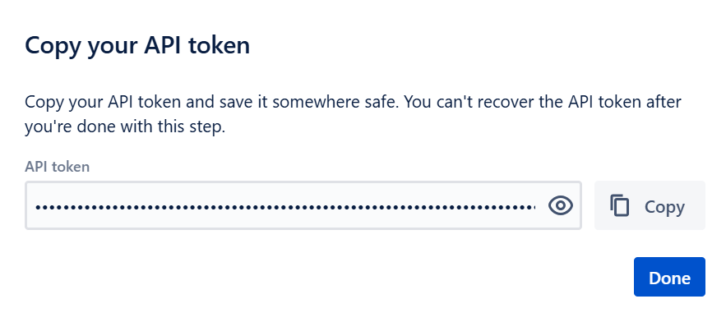

1. **Design Changes:**
2. **Please follow attached design document for New Clients –**



1. **Please follow below steps for clients those are already using POV –**

* Please see below attached updated Studio CLAR file.



* Configure the integration attributes as below:

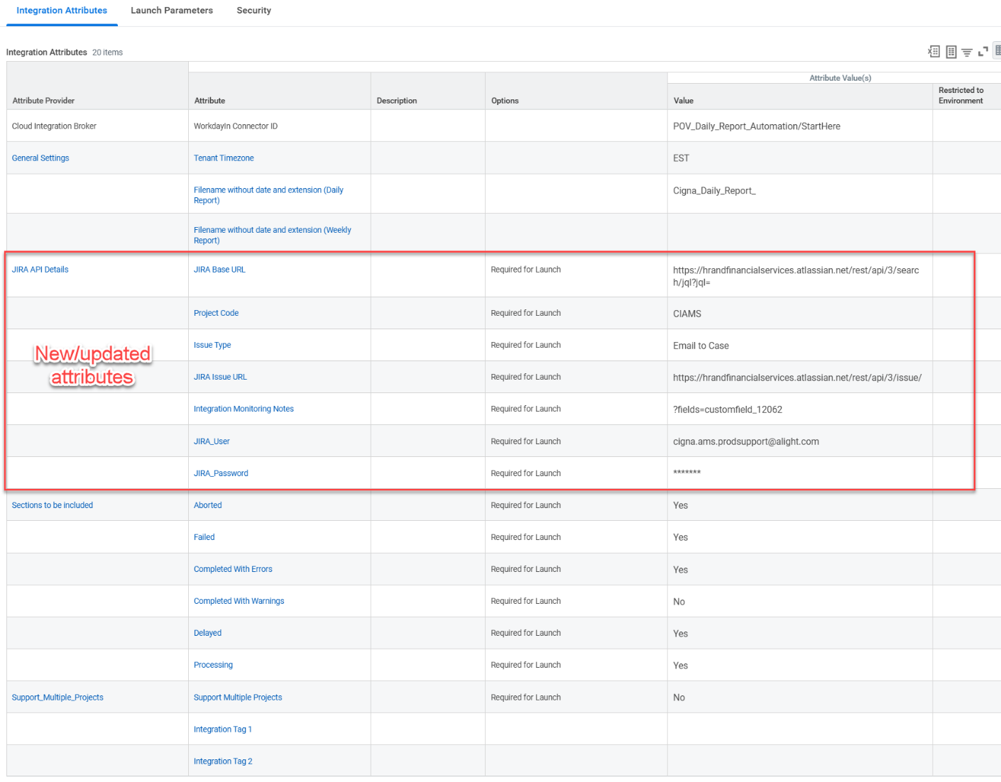

* Tenant Timezone - *Same as your existing value*
* Filename without date and extension (Daily Report) - *Same as your existing value*
* Filename without date and extension (Weekly Report) - *Same as your existing value*
* **JIRA Base URL** - <https://hrandfinancialservices.atlassian.net/rest/api/3/search/jql?jql=>
* **Project Code** – Project key from JIRA
* **Issue Type** – Type of JIRA issue/ticket created for integration failure – Sample Values Email to Case, Epic
* **JIRA Issue URL** - <https://hrandfinancialservices.atlassian.net/rest/api/3/issue/>
* **Integration Monitoring Notes** - ?fields=customfield_12062
* **JIRA_User** – Username for JIRA Atlassian account
* **JIRA_Password** – Access token for JIRA Atlassian account
* Sections to be included – Click yes for the section you want to include - *Same as your existing value.*
* Support Multiple Projects – Select Yes if there are two AMS projects for your client. If this is set to Yes, then add values for Integration Tag in the input file Integration_Names.csv and configure the same in Integration Tag 1and Integration Tag 2 - *Same as your existing value.*

1. **Maintenance:**

API token will expire in 1 year, hence need to regenerate the API token before expiry date.